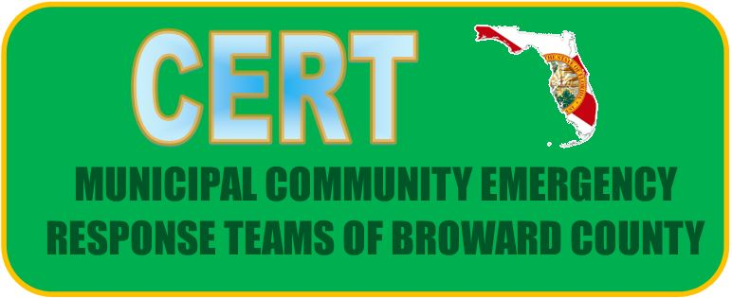
Sub Committee Report for May 5th 2022

Meeting was held in Person on April 26, 2022
9 Teams of 15 in attendance
Social Media Was discussed and the Facebook Page was voted to go live.
- Interested parties can Search MCERT
- Municipal Community Emergency Response Teams of Broward
Coincidentally we have been looking for other areas doing this as a collaborative page and have not found one. We will continue to update as we progress.
Newly developed CERT Event Team
- 19 People – From Multiple Teams
- Meeting was held on May 3rd – Great Progress Good Group
Training
Several Trainings are getting underway and being shared amongst the teams
Coral Springs starting a new class May 7th
Plantations Fire Department just completed a Firefighter Rehab Class
Webinar on May 5th with NWS
Volunteer Opportunity at FLL June 23rd, 2022
More to come on classes and training

That Concludes my Report

