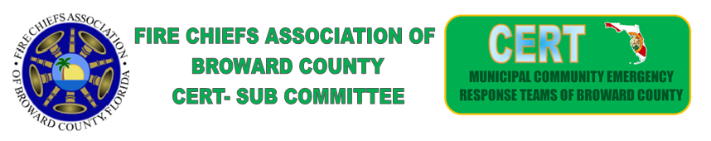
Meeting Held on June 21, 2022
7 Municipalities and Broward EM in attendance
Davie
Tamarac
Pembroke Pines
Plantation
Miramar
Cypress Creek
Cooper City
Broward county

CERT Events

- Meet and greet not enough Participation Cancelled
- TRIAGE and MCI Training No Participation Cancelled
Requested
- Planning a Crowd Management and Traffic Control Opportunity
- Pembrooke Pines – Volunteered to host

Discussion was held on getting current members out, to meetings and events, concerns were raised regarding several issues, we will have to work through those.

- Reports were given by each city in attendance

Discussion was held on Grants and possibly utilizing Grant source to search and write them

Lastly- Discussion and a vote was putto the group regarding Using dollars found in the current CERT account w/ the FCABC for our PSA. We are still waiting on the votes to come in but are close to a majority at this time

